**Oisin Goddard – psyog2 – 20290834**

[Homepage](http://avon.cs.nott.ac.uk/~psyog2/dbicw2.html)

The code in this project is written in HTML, CSS, JavaScript, PHP and SQL. These are the files used:

* dbicw2.html
* dbicw2-search.html
* dbicw2-search.php
* dbicw2-add.html
* dbicw2-add.php
* dbicw2-add2.php
* dbicw2-addActor.html
* dbicw2-addActor.php
* dbicw2-delete.php
* dbicw2-delete2.php
* dbicw2-delete3.php
* dbicw2-deleteActor.php
* dbicw2-delete2Actor.php
* dbicw2-delete3Actor.php
* dbicw2.js
* dbicw.css
* dbicw2-delete.png

**Home**

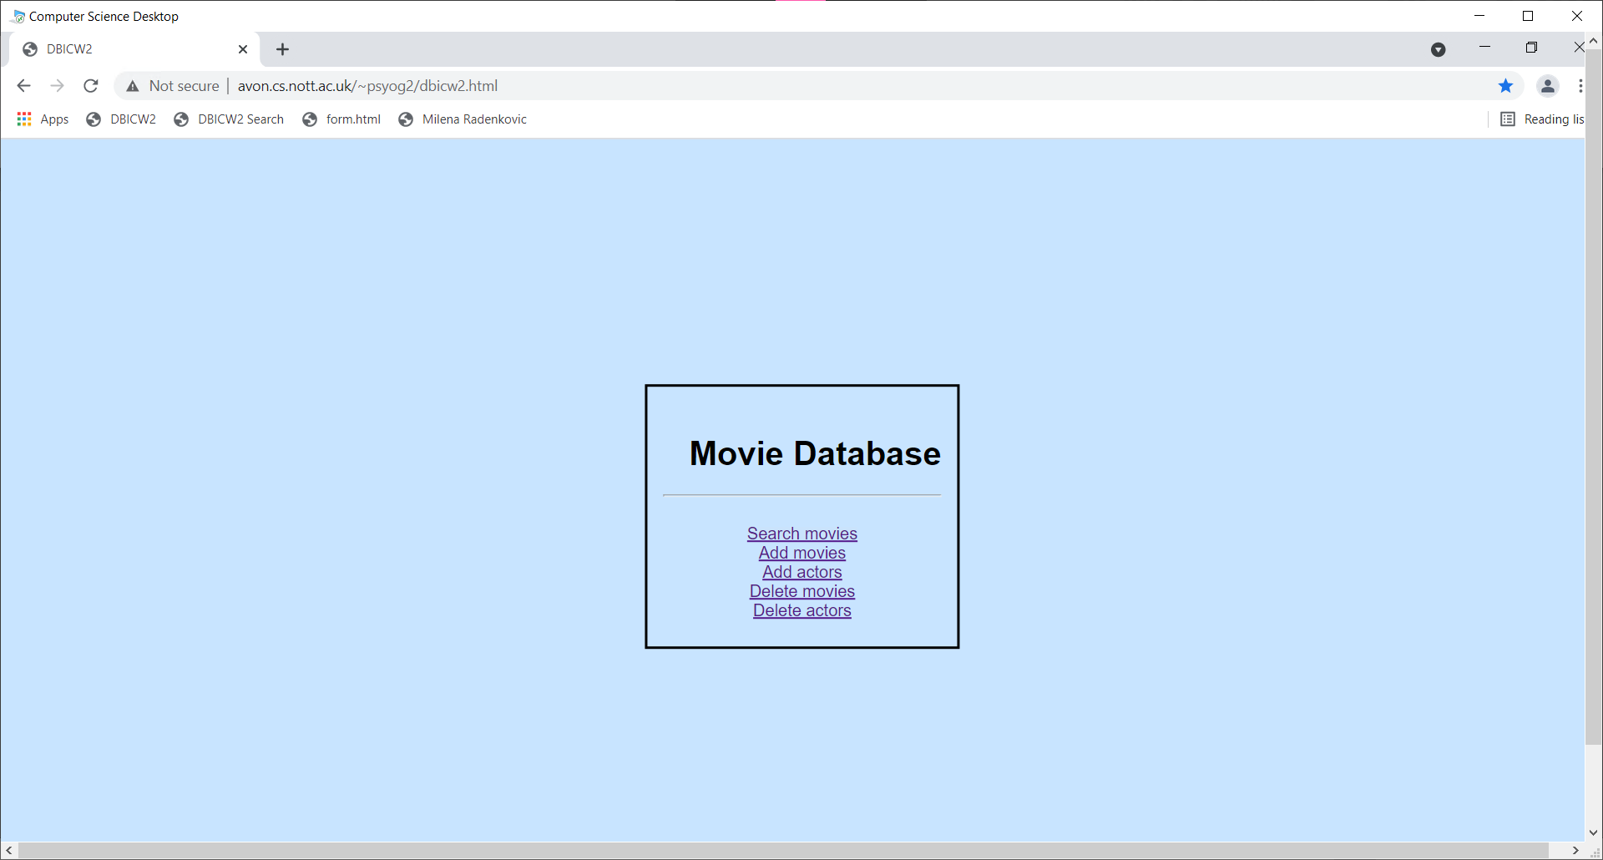Basic navigation box

**Search**

Search box with submit button. User can search by title, genre, or actor. User is notified in the event of an empty search.

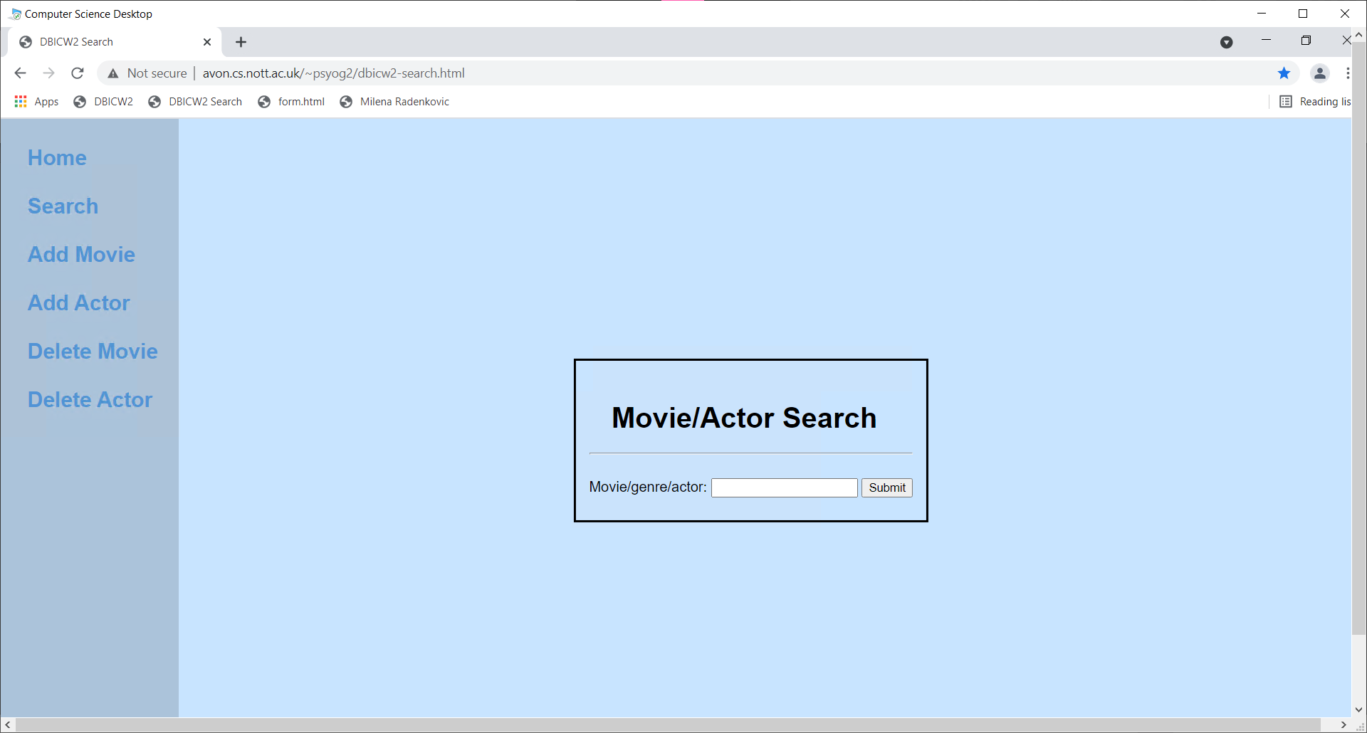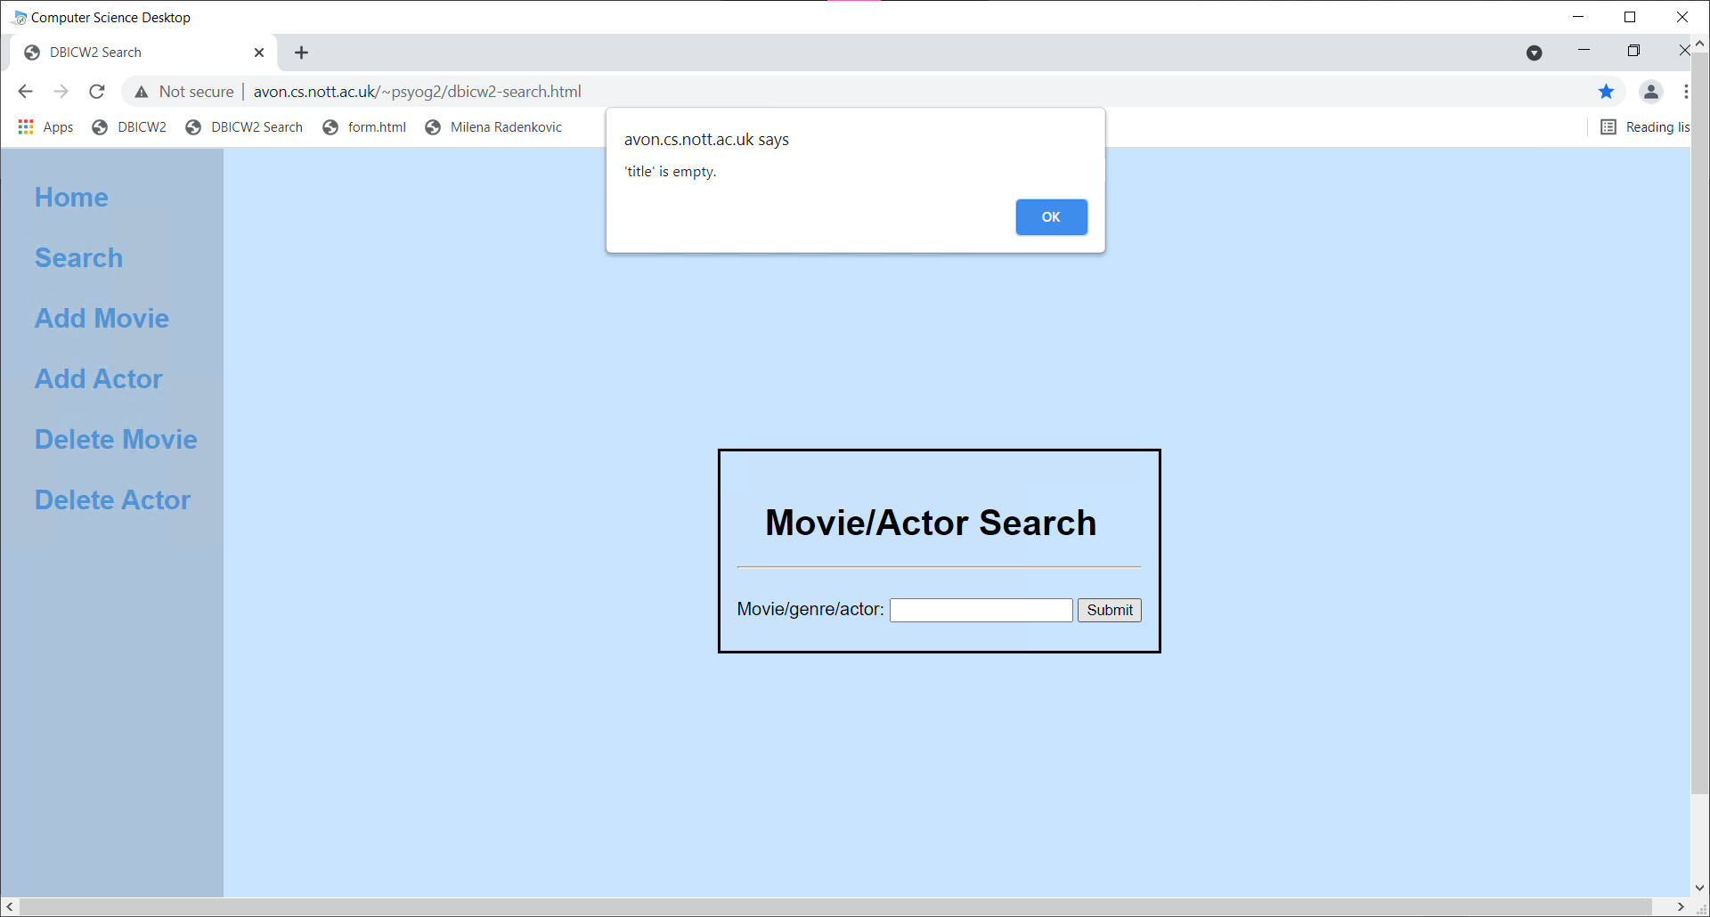

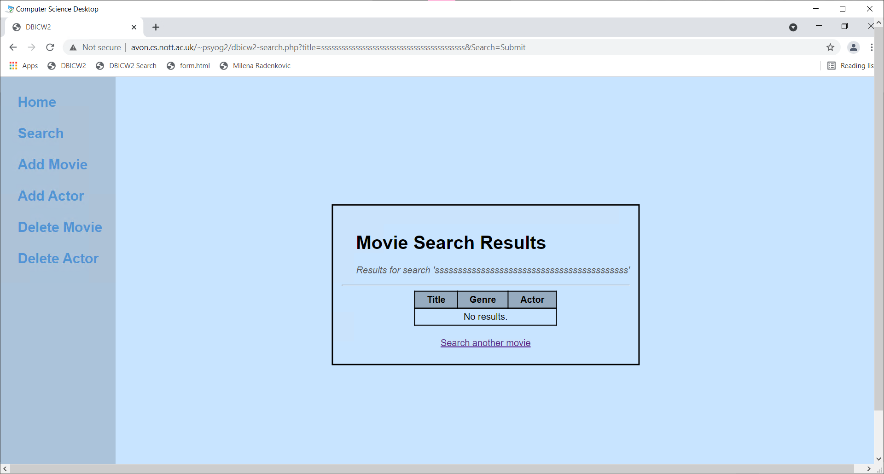**Add Movie**

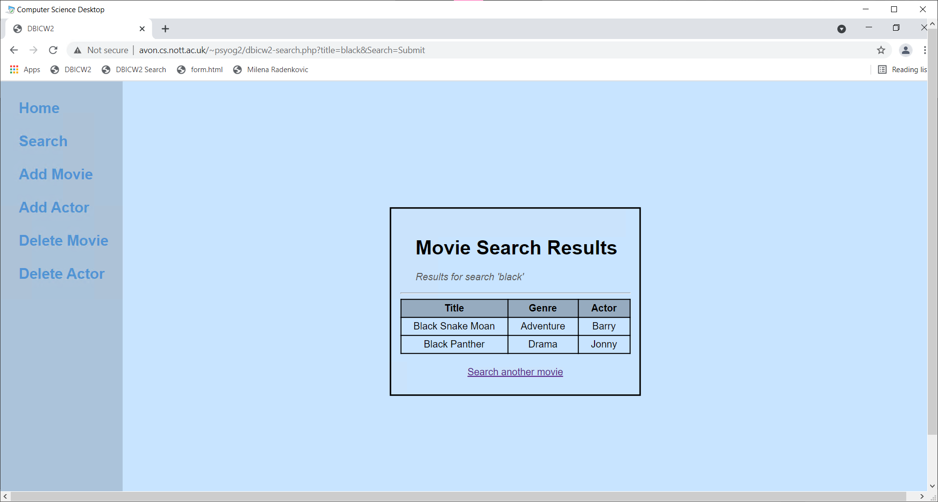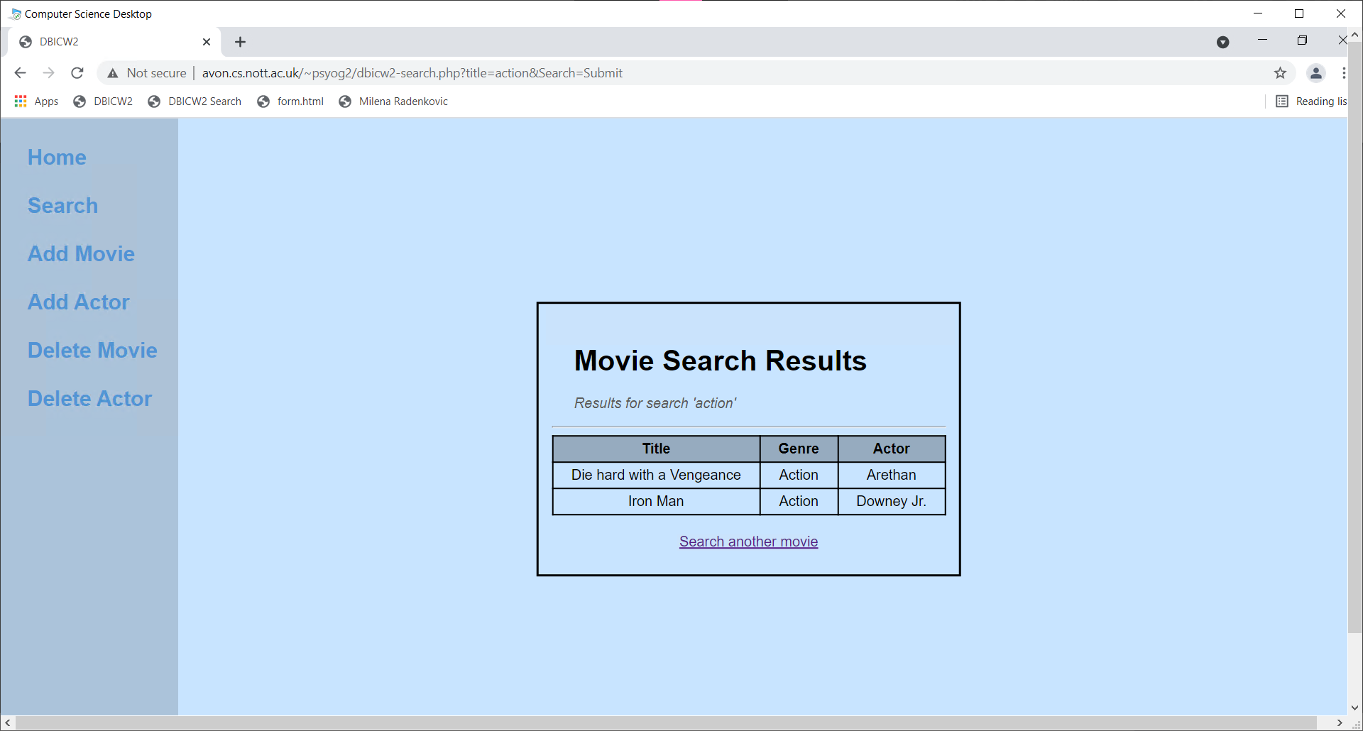

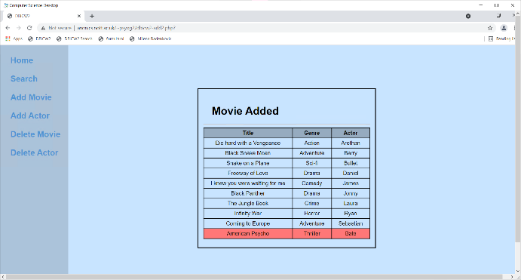User inputs title, selects genre, inputs actor. User is asked if they want to add the movie. Movie is then shown at the bottom of the database highlighted red to indicate it was added. Actor is added to database if not already existing.

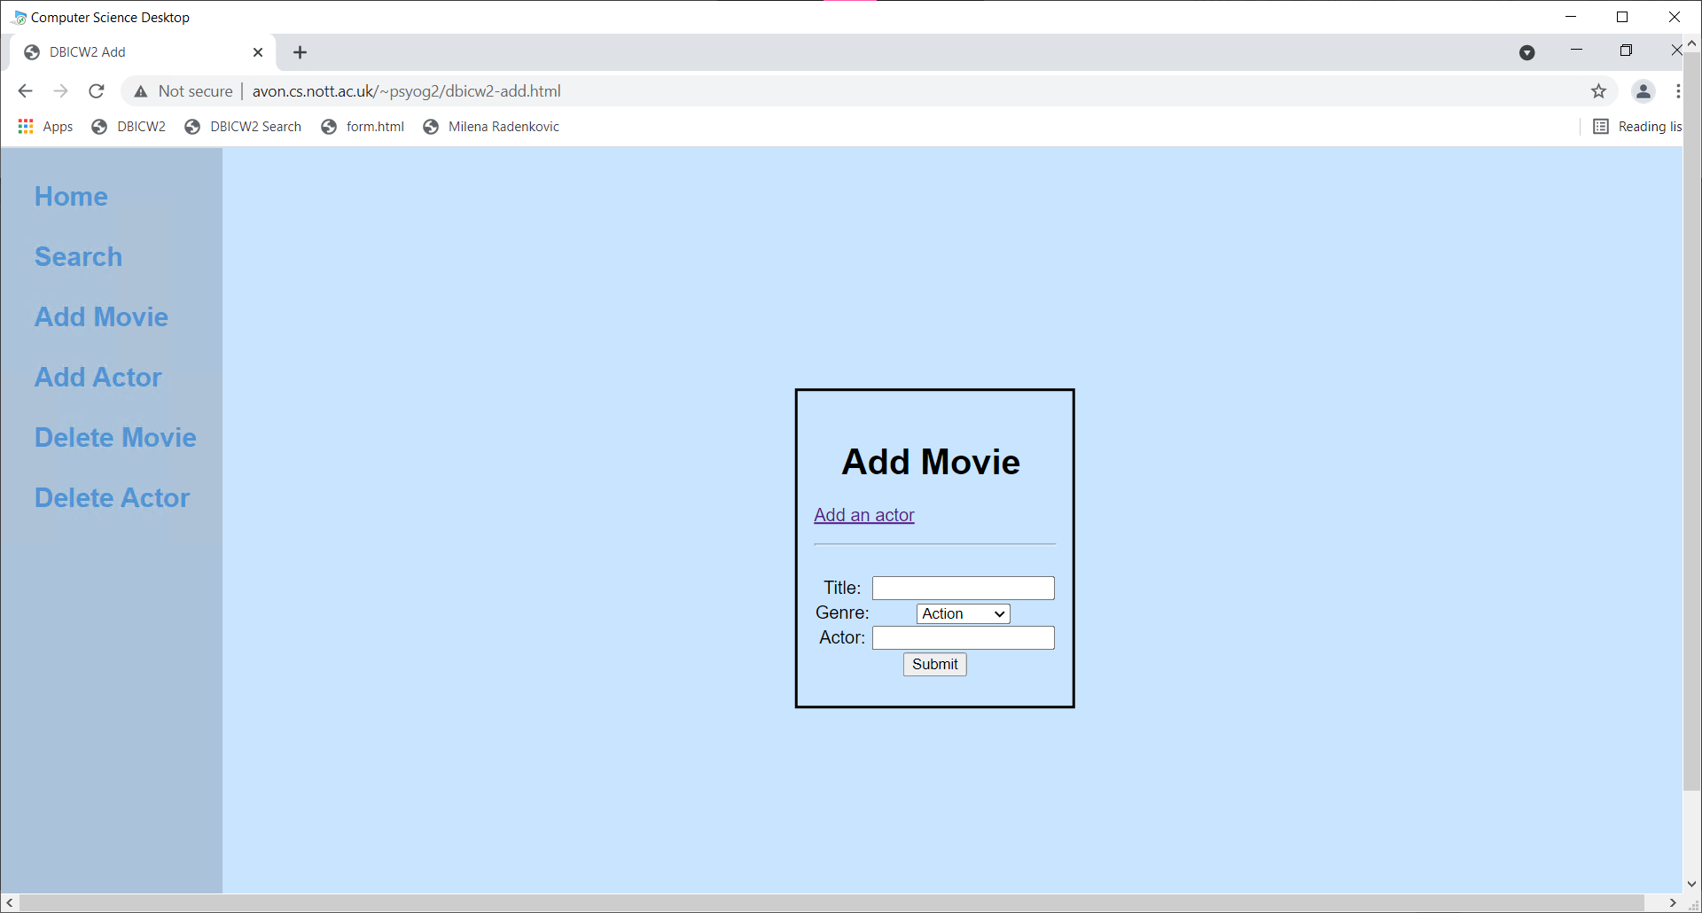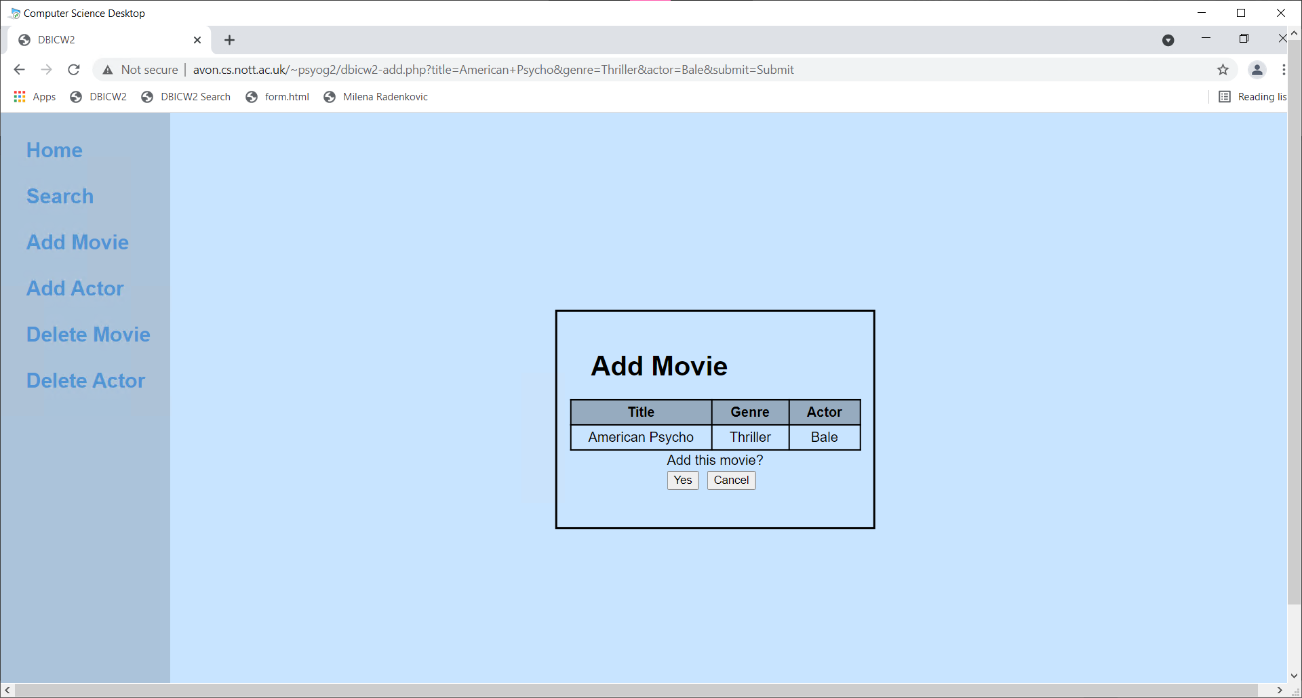

**Add Actor**

User is prompted for actor name, it is added.

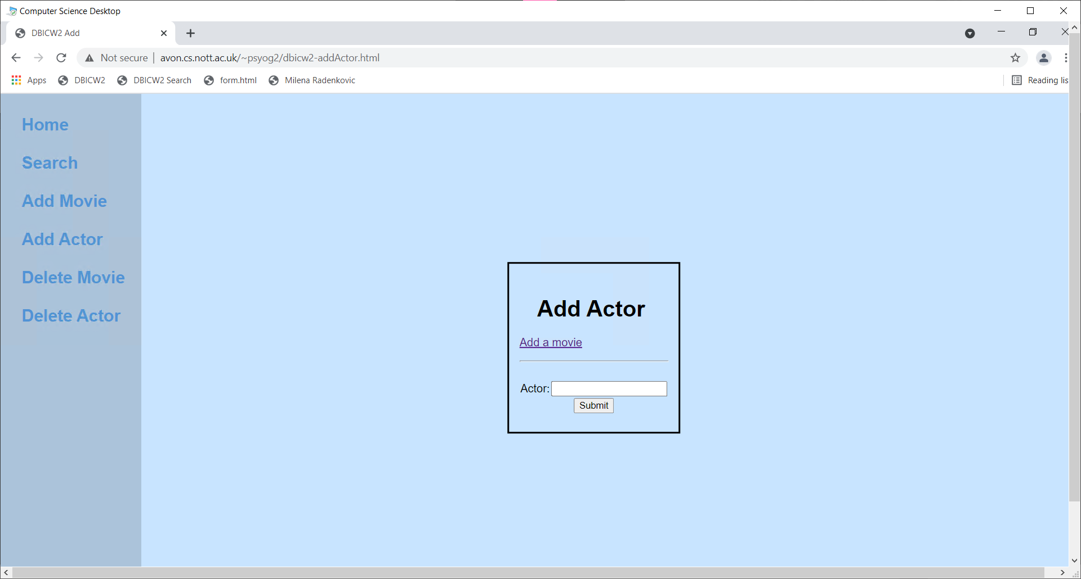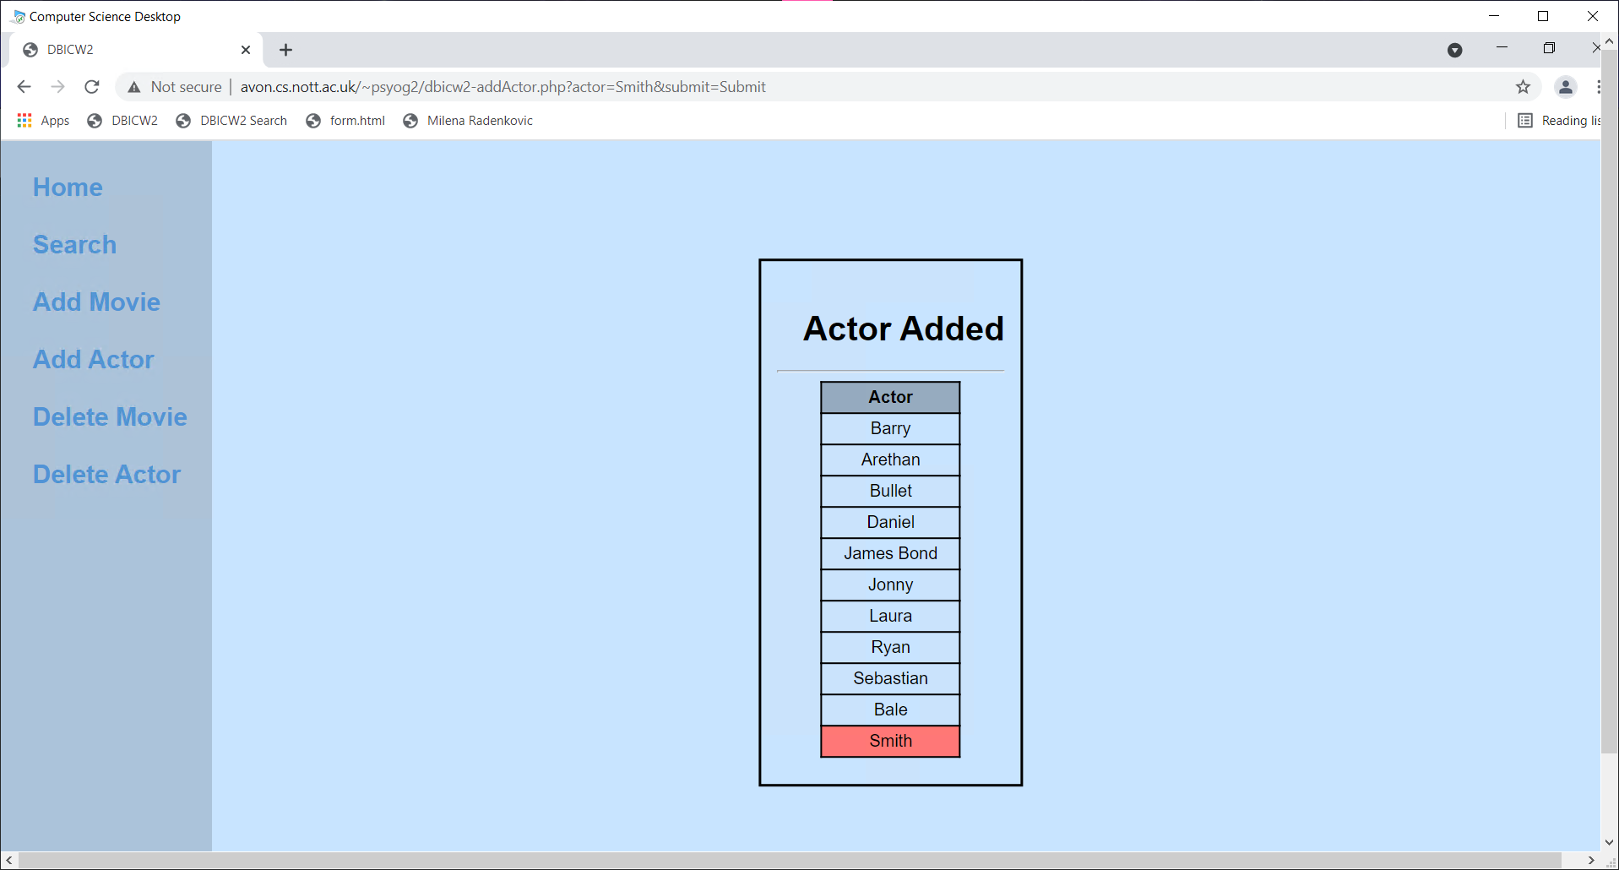

**Delete Movie**

User selects which movie to delete via the bin icon. They are asked if they want to delete the movie. The movie is shown with strikethroughs to indicate it was deleted.

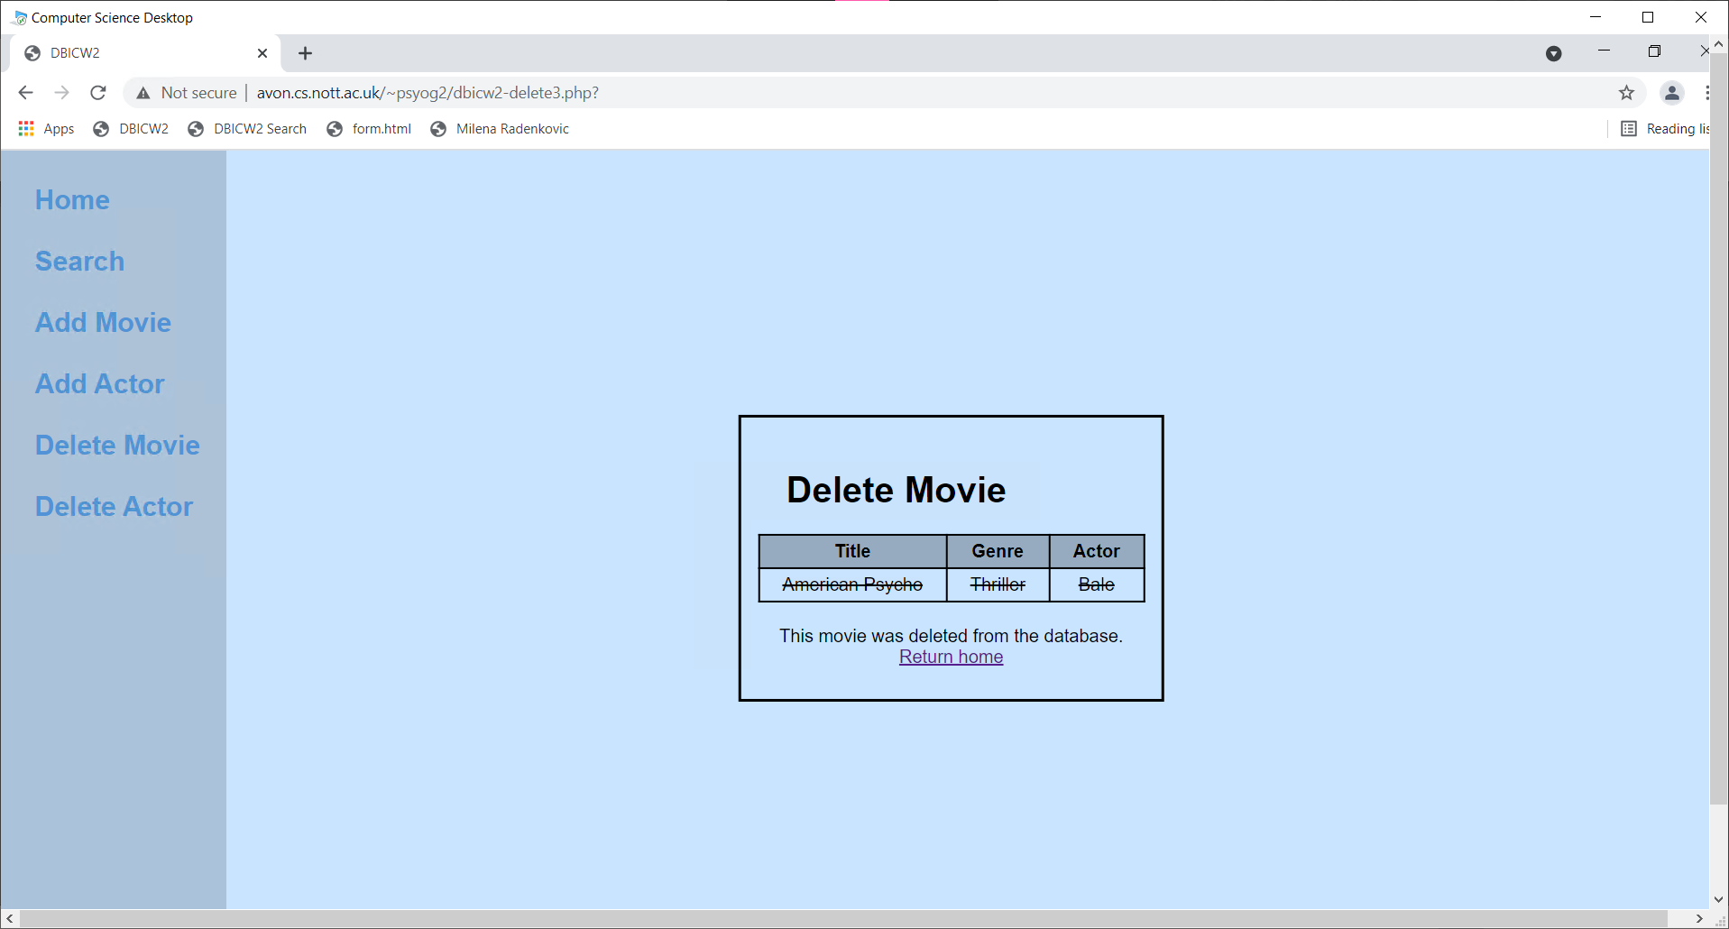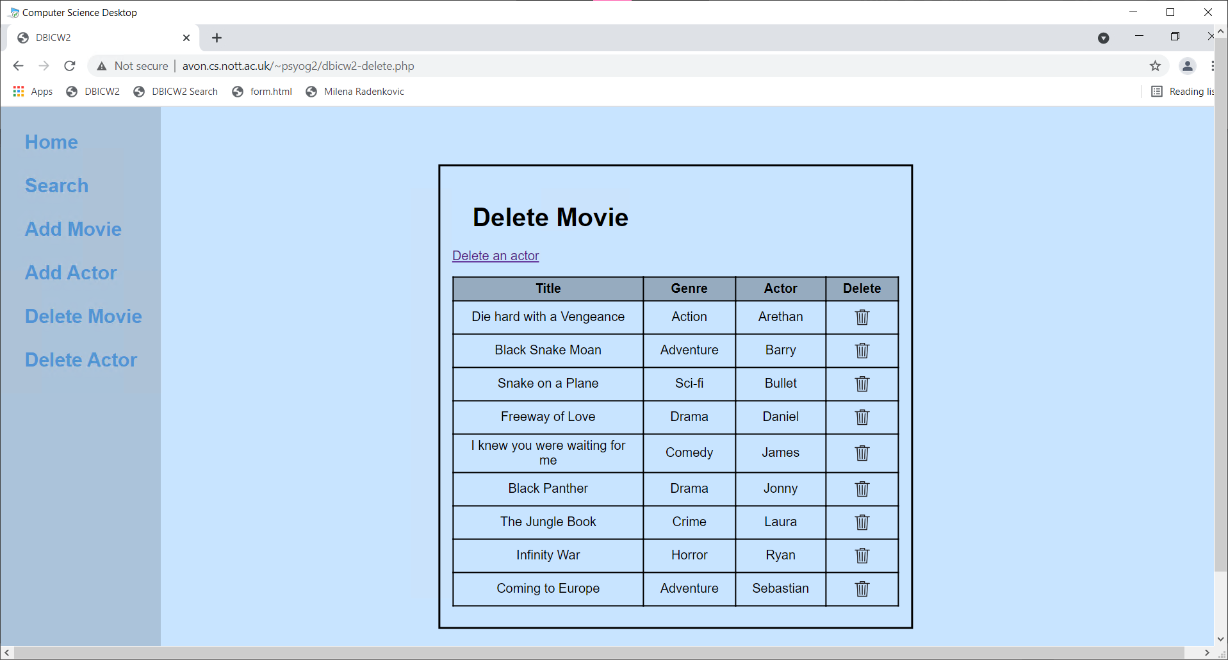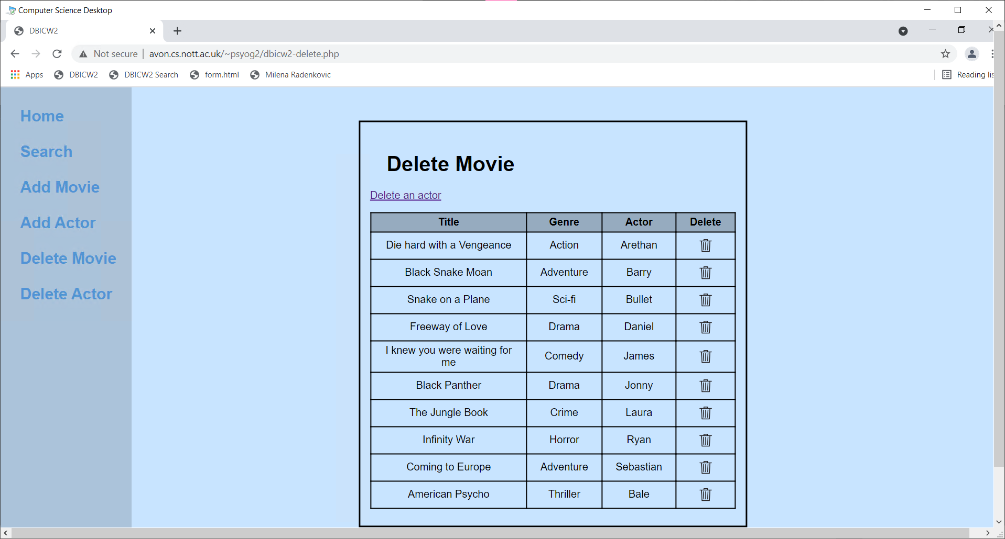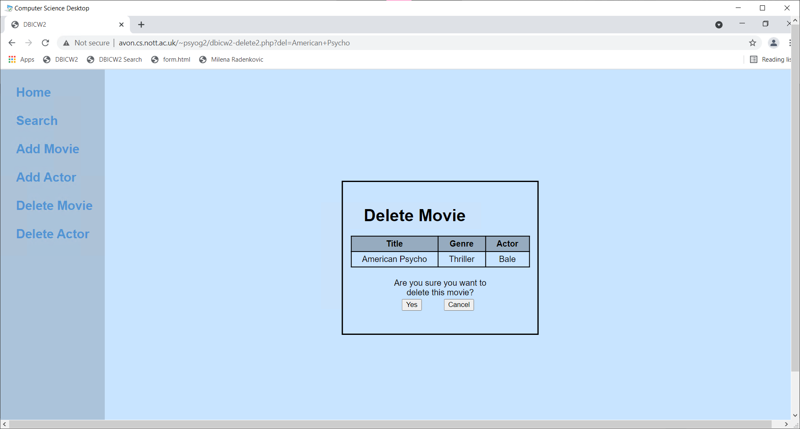

**Delete Actor**

User selects which actor to delete via the bin icon. They are asked if they want to delete the actor. If the actor appears in a movie then they are not deleted (foreign key constraints). The actor is shown with strikethroughs to indicate it was deleted.

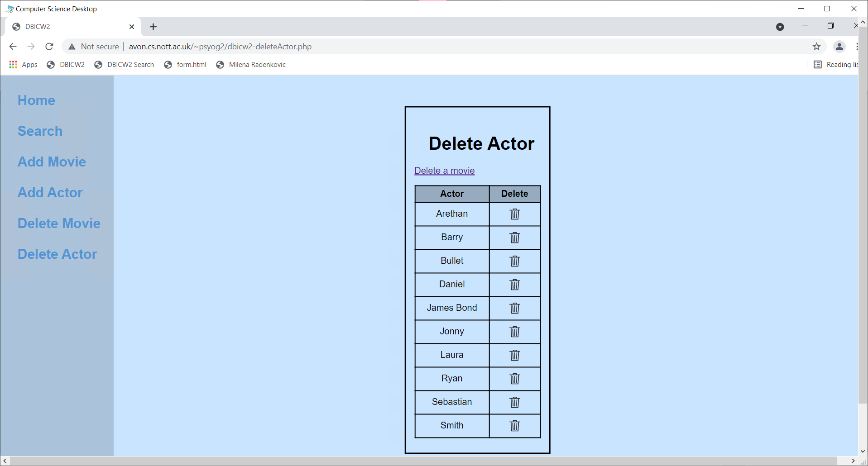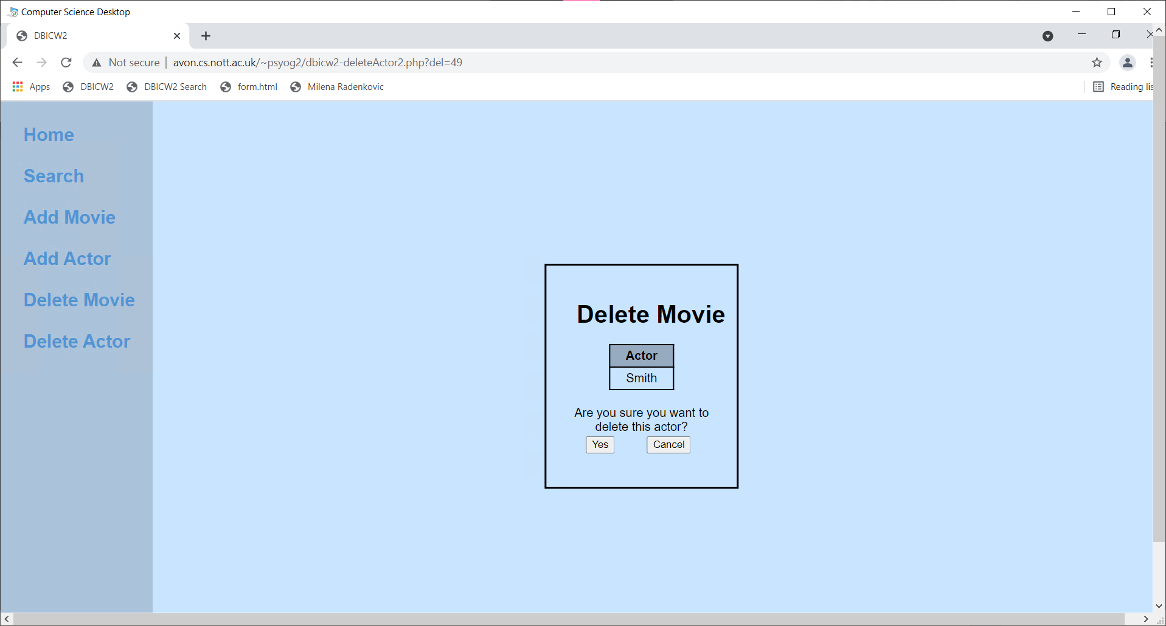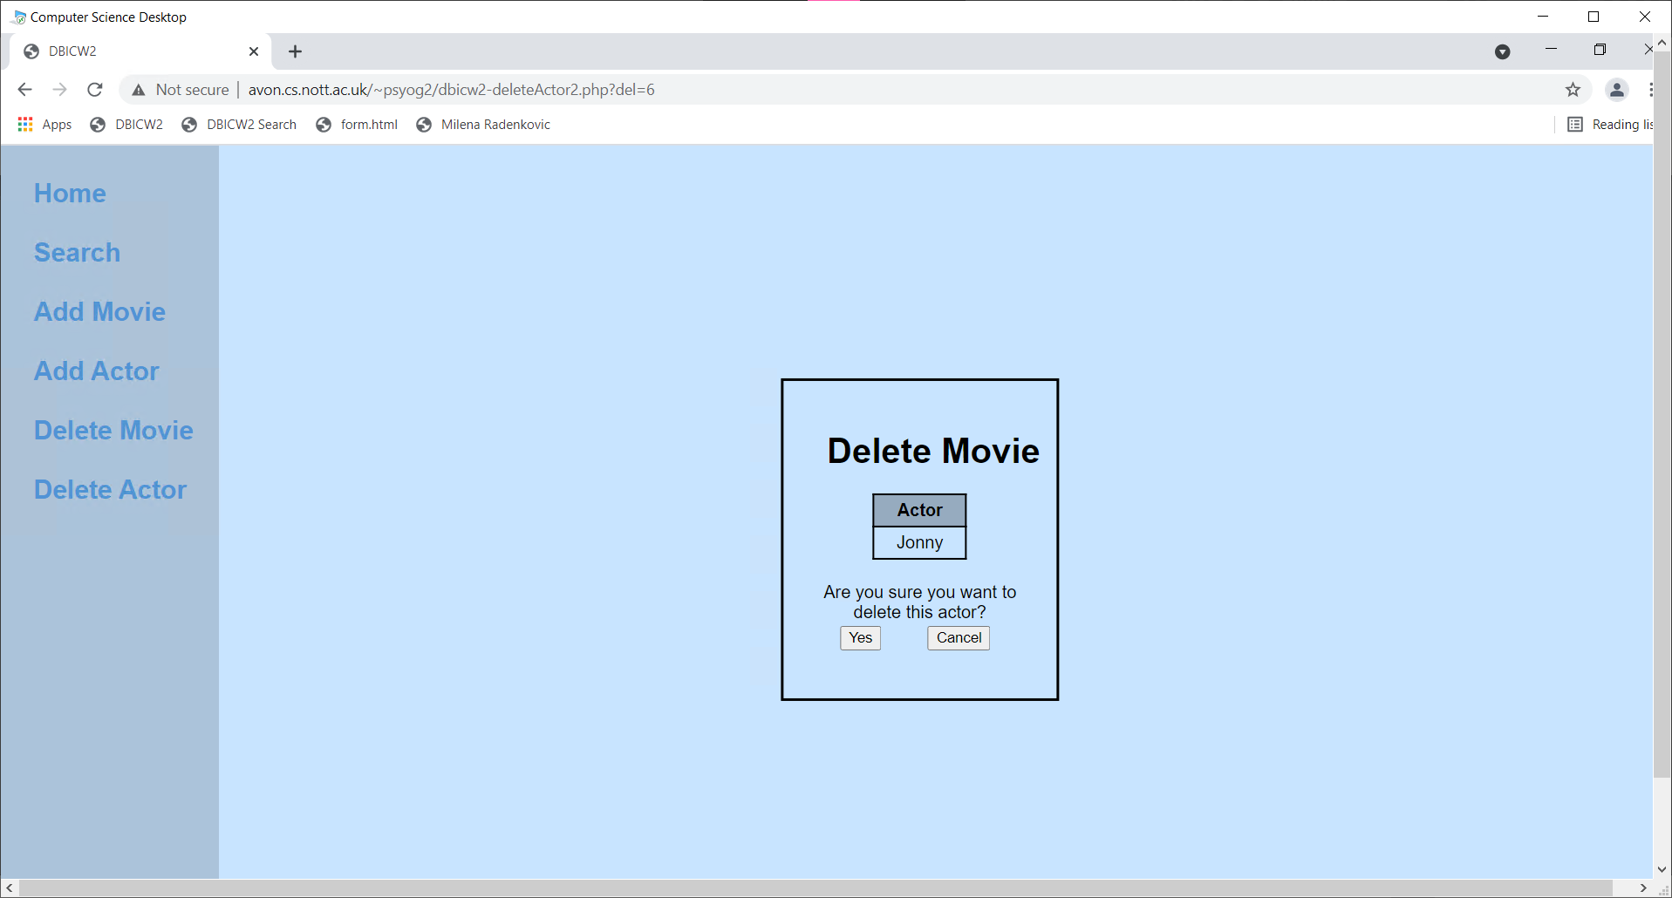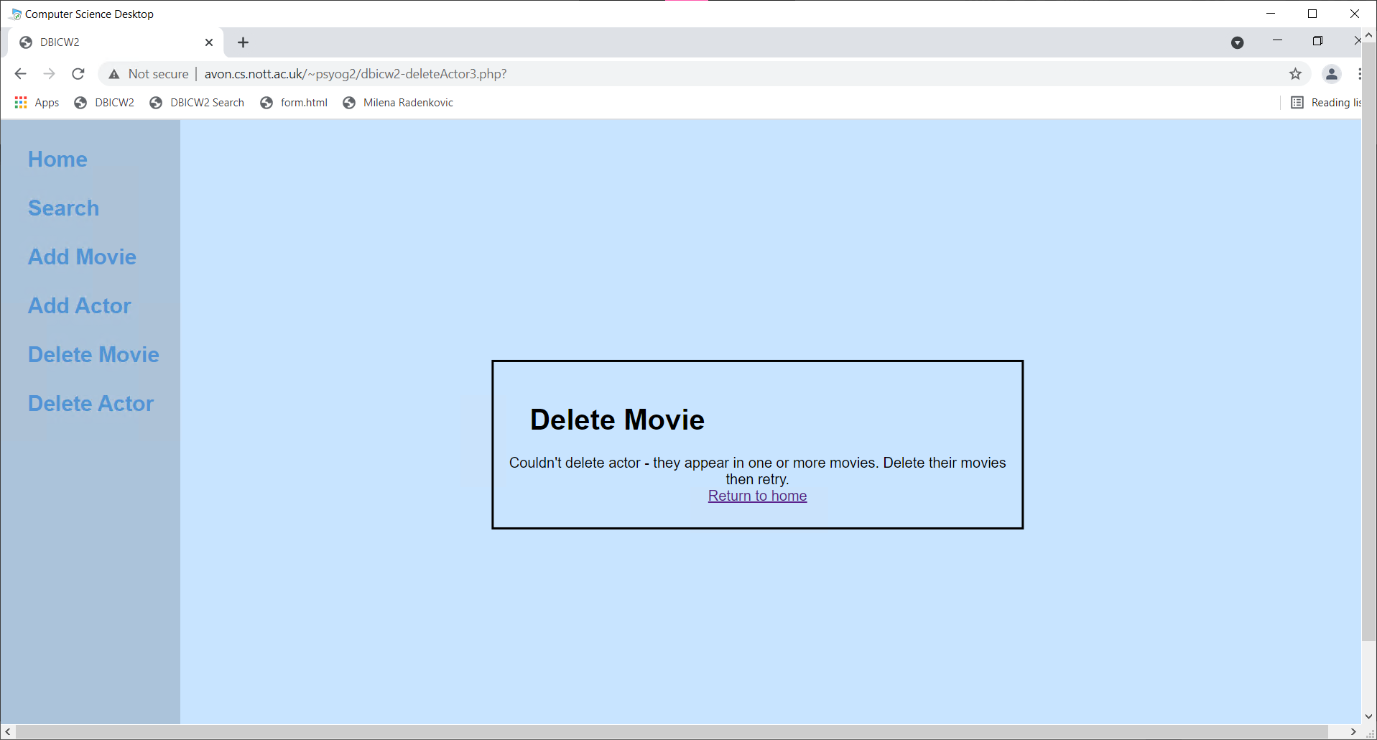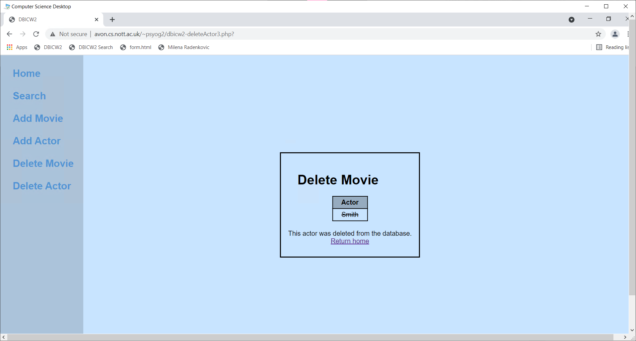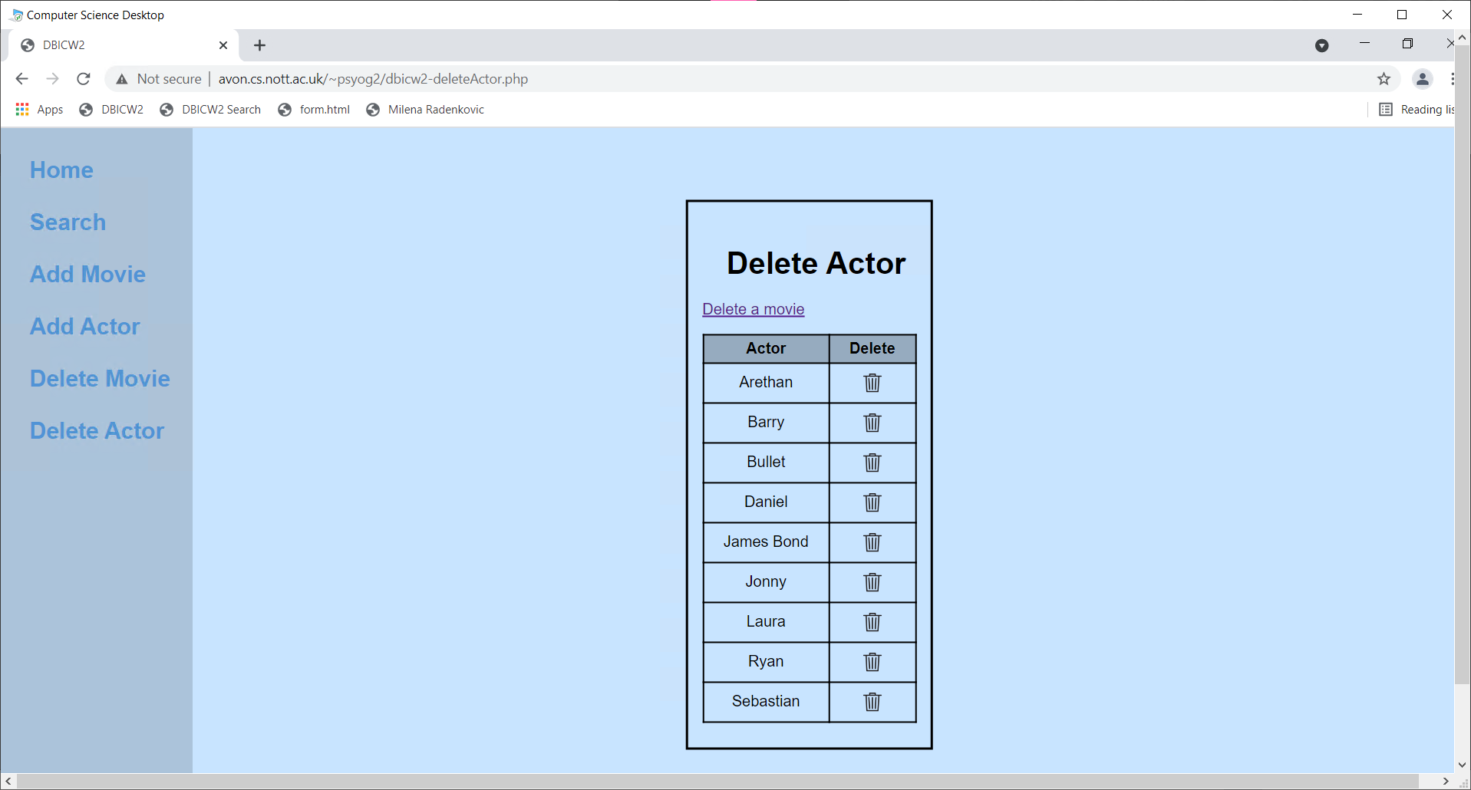

**Other**

There is a sidebar on the left side of all pages except the home page. The links are to their respective pages. The sidebar darkens on hover and the links brighten.

